

**Sneaker Online Shop System**

**Software Design Specification**

– Hanoi, April 2023 –

**Record of changeS**

| **Date** | **A* M, D** | **In charge** | **Change Description** |
| --- | --- | --- | --- |
|  |  |  |  |
|  |  |  |  |
|  |  |  |  |
|  |  |  |  |
|  |  |  |  |
|  |  |  |  |
|  |  |  |  |
|  |  |  |  |
|  |  |  |  |
|  |  |  |  |
|  |  |  |  |
|  |  |  |  |
|  |  |  |  |

*A - Added M - Modified D - Deleted

**Table of Contents**

I. Overview

1. Code Packages

2. Database Design

a. Database Schema

b. Table Description

II. Code Designs

1. Login

a. Class Diagram

b. Class Specifications

c. Sequence Diagram(s)

d. Database queries

2. Sign Up

a. Class Diagram

b. Class Specifications

c. Sequence Diagram(s)

d. Database queries

3. Order

a. Class Diagram

b. Class Specifications

c. Sequence Diagram(s)

d. Database queries

4. CRUD

a. Class Diagram

b. Class Specifications

c. Sequence Diagram(s)

d. Database queries

5. ProductList

a. Class Diagram

b. Class Specifications

c. Sequence Diagram(s)

d. Database queries

6. Filter

a. Class Diagram

b. Class Specifications

c. Sequence Diagram(s)

d. Database queries

7. Search

a. Class Diagram

b. Class Specifications

c. Sequence Diagram(s)

d. Database queries

8. Admin Dashboard

a. Class Diagram

b. Class Specifications

c. Sequence Diagram(s)

d. Database queries

9. View profile

a. Class Diagram

b. Class Specifications

c. Sequence Diagram(s)

d. Database queries

10. Product Detail

a. Class Diagram

b. Class Specifications

c. Sequence Diagram(s)

d. Database queries

# I. Overview

## 1. Code Packages

***Package descriptions***

## 2. Database Design

### a. Database Schema

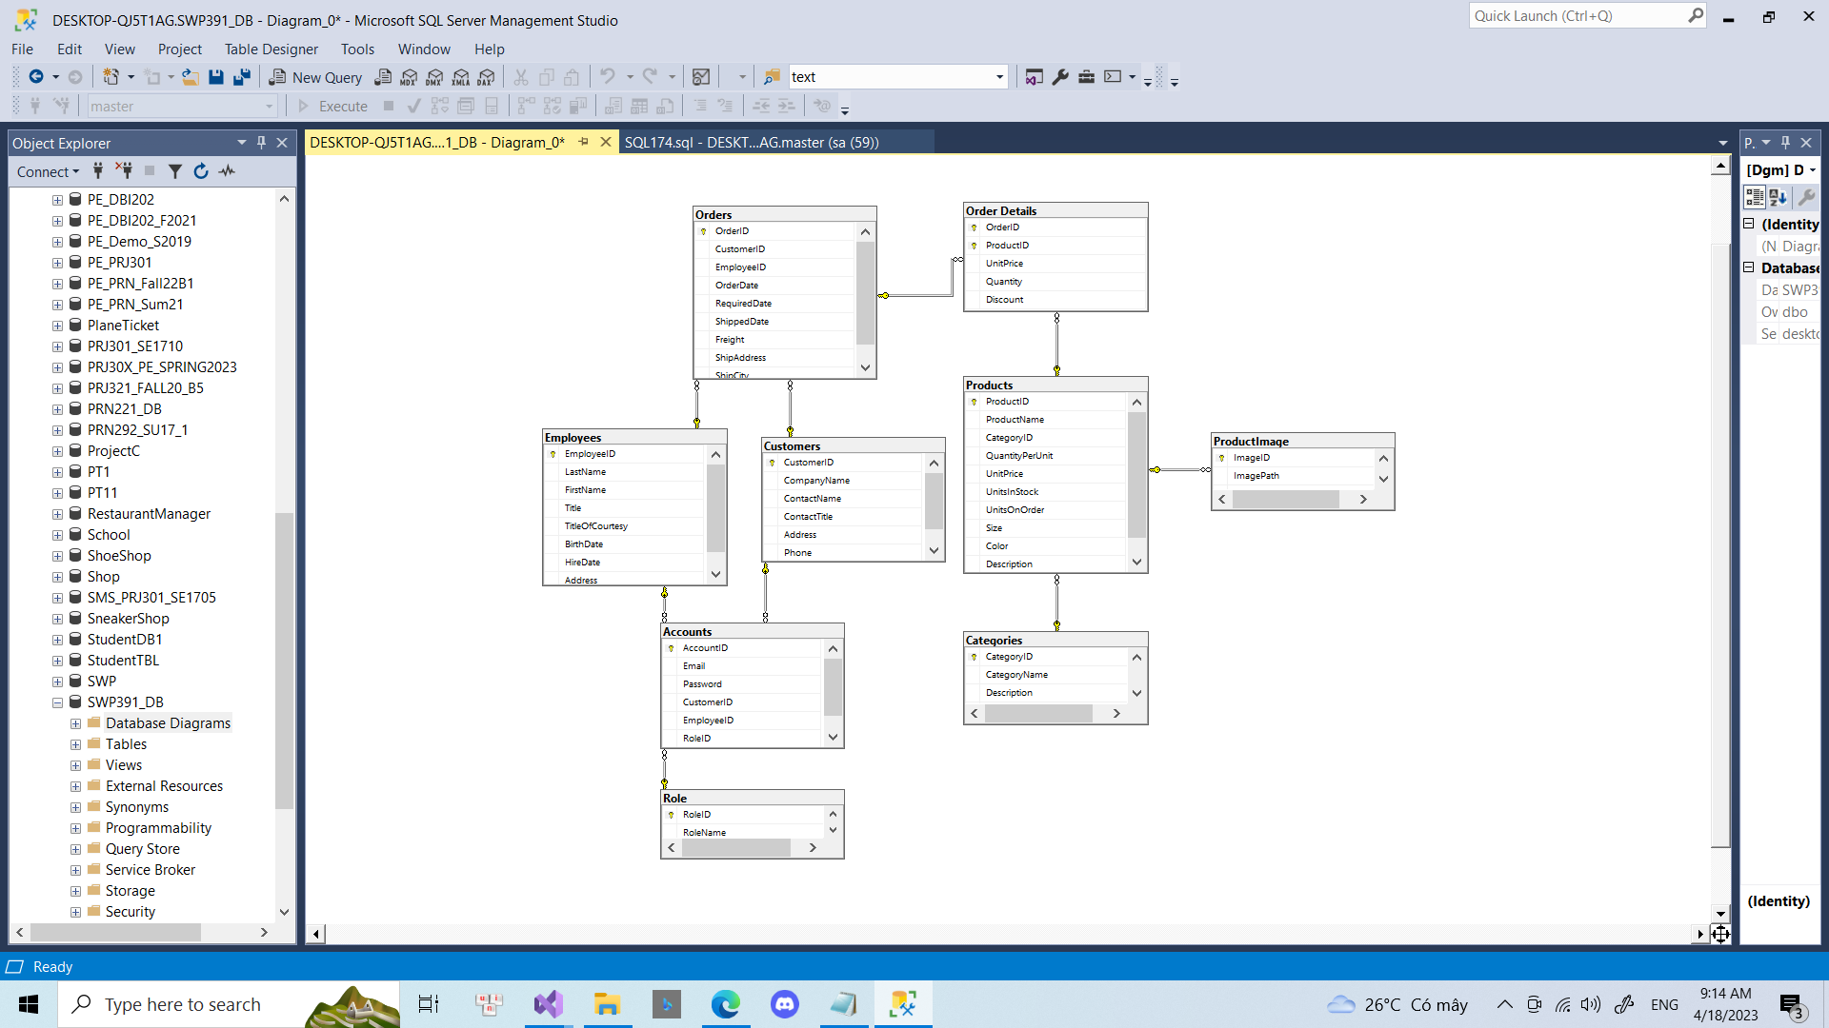

### b. Table Description

#### 

| **No** | **Table** | **Description** |
| --- | --- | --- |
| *01* | *Accounts* | *Get value of Accounts* |
| *02* | *Customers* | *Get value of Customers* |
| *03* | *Employees* | *Get value of Employees* |
| *04* | *Role* | *Contain role of admin/employee/customer* |
| *05* | *Orders* | *Get value of Order* |
| *06* | *ProductImage* | *Contain url of image of product* |
| *07* | *Products* | *Get value of Products* |
| *08* | *Order Details* | *Contain details value of a order* |
| *09* | *Categories* | *Get value of Categories* |

# II. Code Designs

## 1. Login

### a. Class Diagram

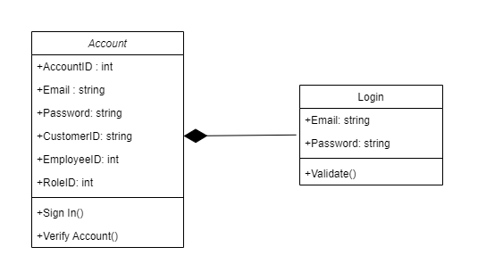

### b. Class Specifications

#### Account

| **No** | **Method** | **Description** |
| --- | --- | --- |
| *01* | *getter/setter* | *Get value of private attributes* |
|  |  |  |

***DBContext Class***

| **No** | **Method** | **Description** |
| --- | --- | --- |
| *01* | *getConnection()* | *class attempts to establish a connection to the database by using the given database url.* |

### c. Sequence Diagram(s)

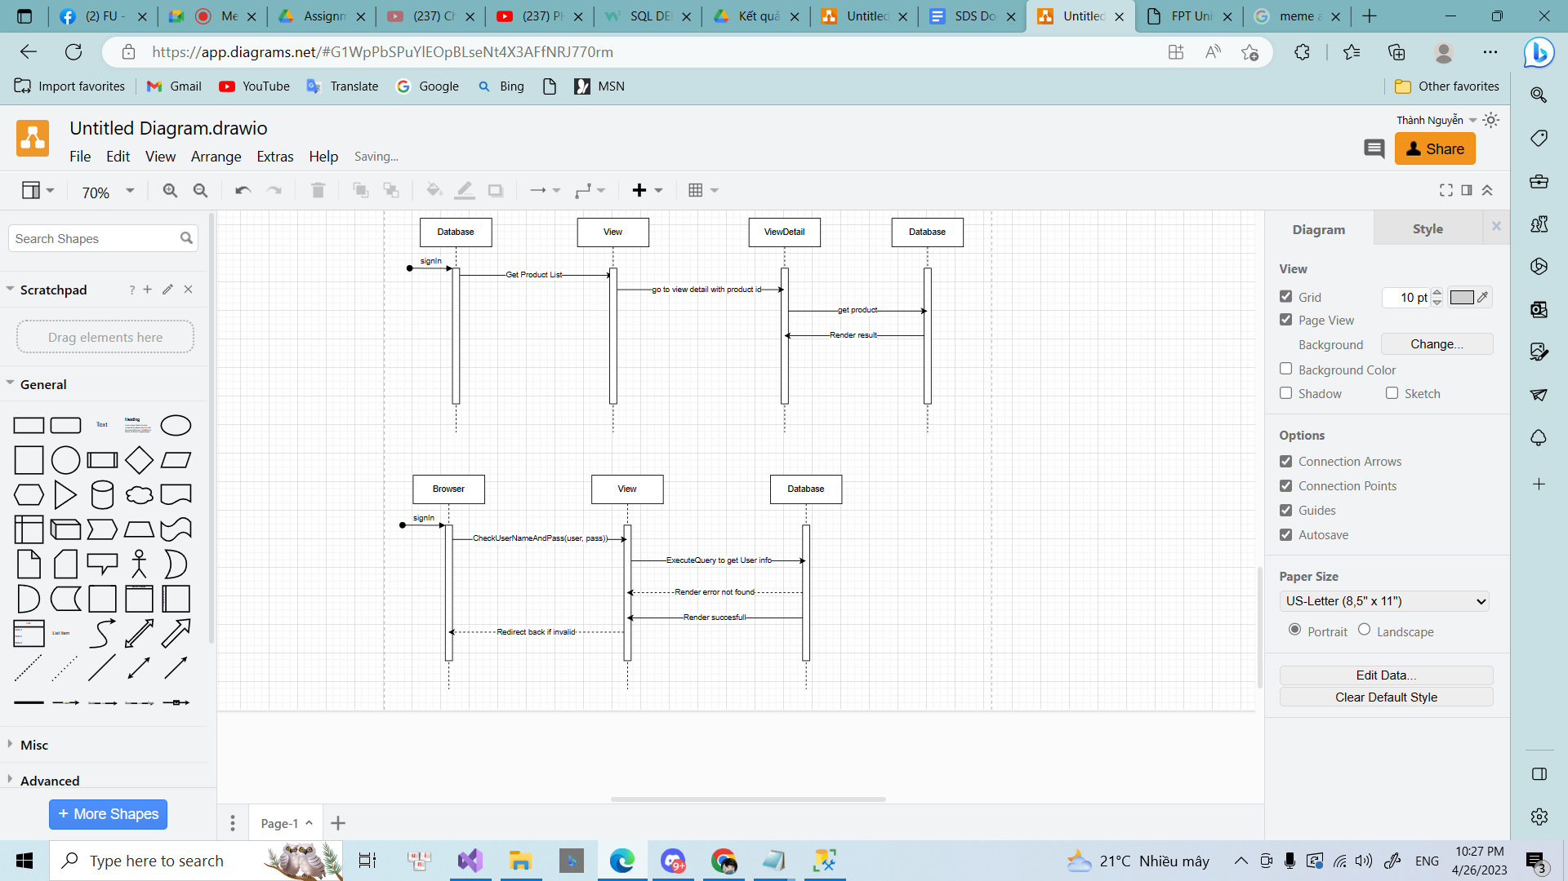

### d. Database Queries

await dBContext.Accounts.Where(

a => a.Email.Equals(account.Email) && a.Password.Equals(account.Password)).SingleOrDefaultAsync()

## 2. Sign up

### a. Class Diagram

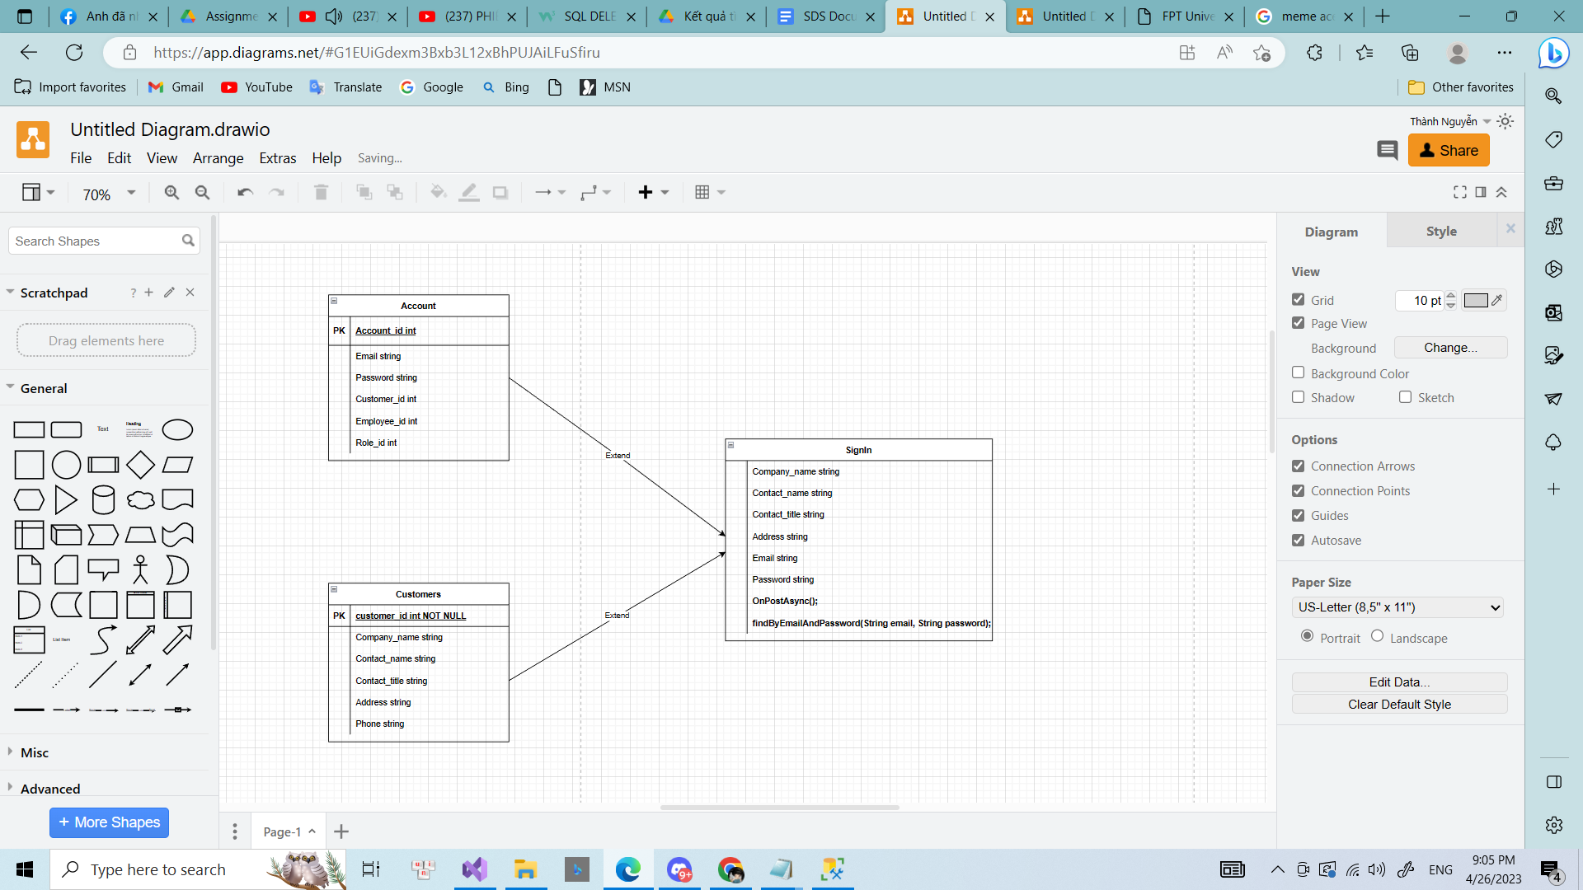

### b. Class Specifications

#### Account

| **No** | **Method** | **Description** |
| --- | --- | --- |
| *01* | *getter/setter* | *Get value of private attributes* |
|  |  |  |

#### Customer

| **No** | **Method** | **Description** |
| --- | --- | --- |
| *01* | *getter/setter* | *Get value of private attributes* |
|  |  |  |

### 

### DBContext Class

| No | Method | Description |
| --- | --- | --- |
| 01 | getConnection() | class attempts to establish a connection to the database by using the given database url. |

### 

### c. Sequence Diagram(s)

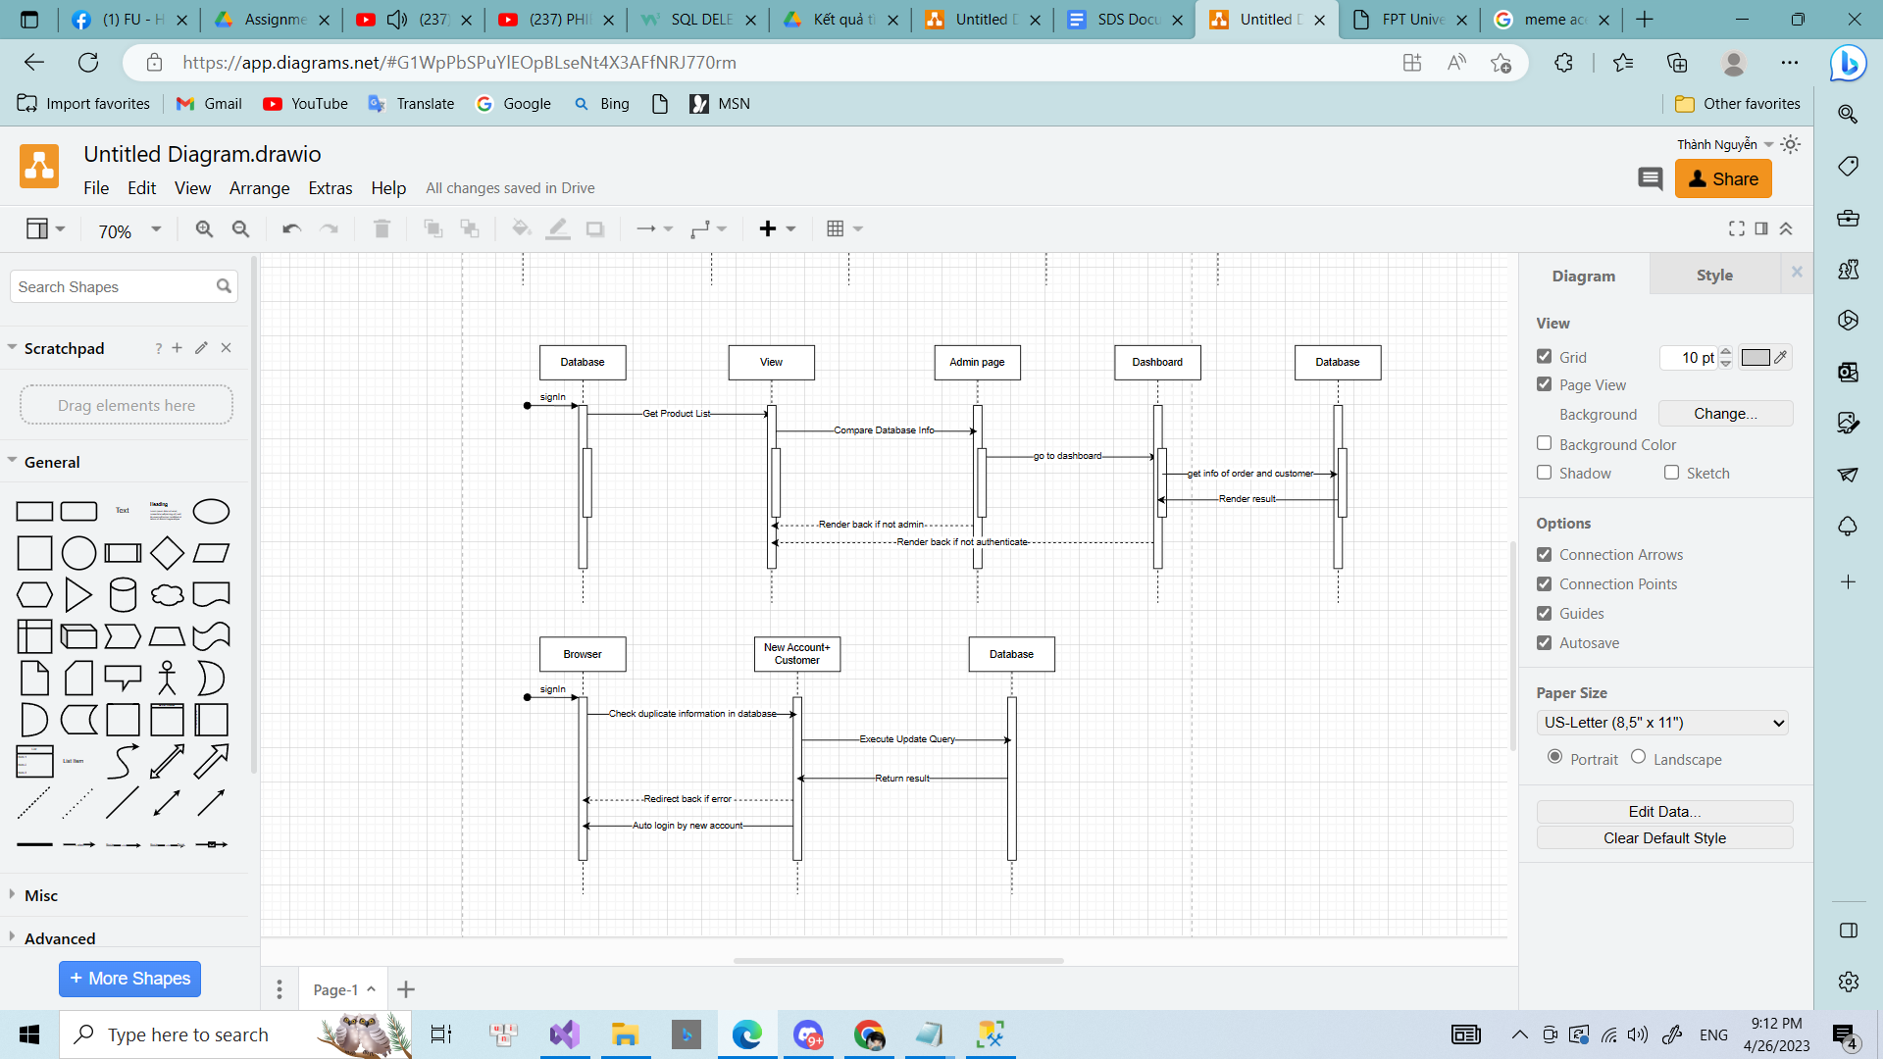

### d. Database Queries

await dBContext.Accounts.Where(

a => a.Email.Equals(account.Email) && a.Password.Equals(account.Password)).SingleOrDefaultAsync();

## 3. Order

### a. Class Diagram

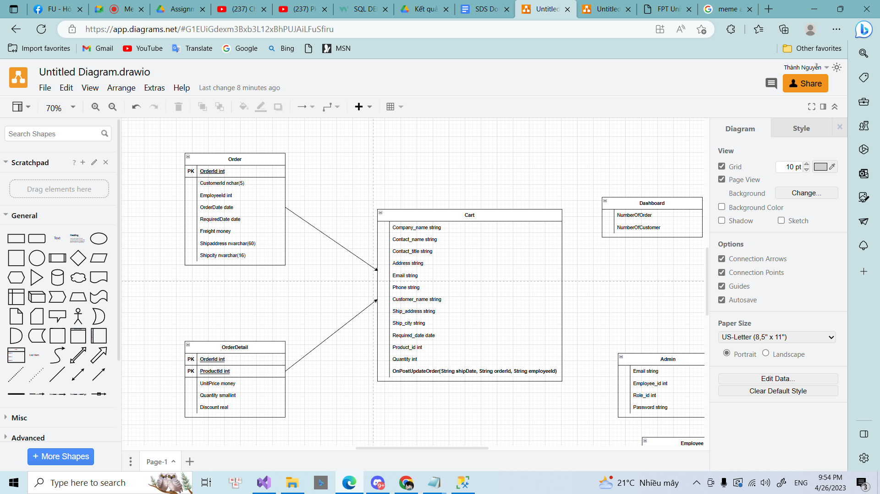

### b. Class Specifications

#### Order

| **No** | **Method** | **Description** |
| --- | --- | --- |
| *01* | *getter/setter* | *Get value of private attributes* |
|  |  |  |

### DBContext Class

| No | Method | Description |
| --- | --- | --- |
| 01 | getConnection() | class attempts to establish a connection to the database by using the given database url. |

### 

### c. Sequence Diagram(s)

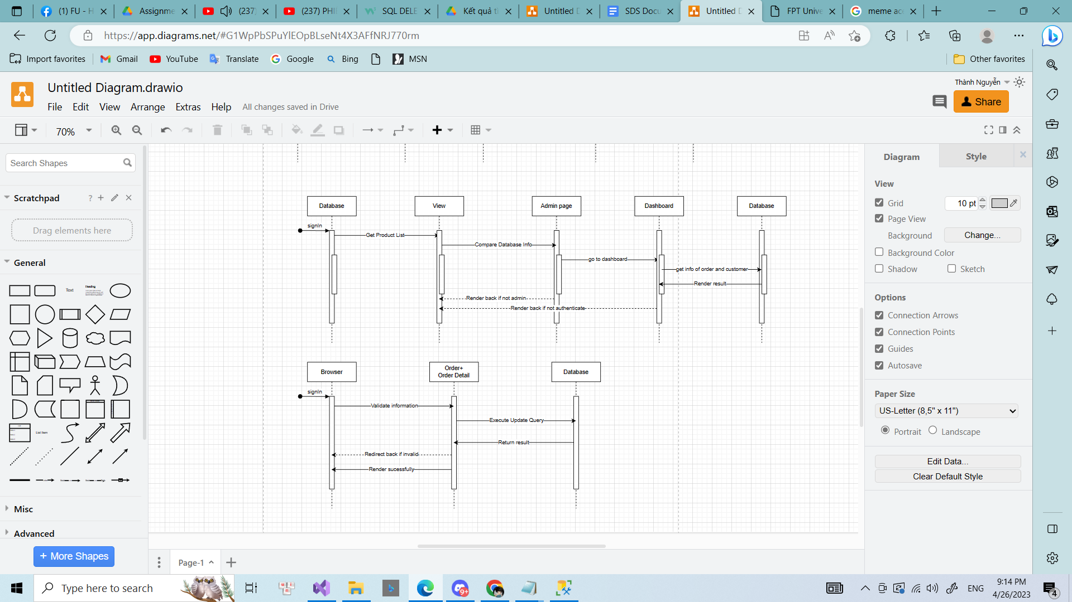

### d. Database Queries

_dbContext.Orders.toList();

## 4. CRUD

### a. Class Diagram

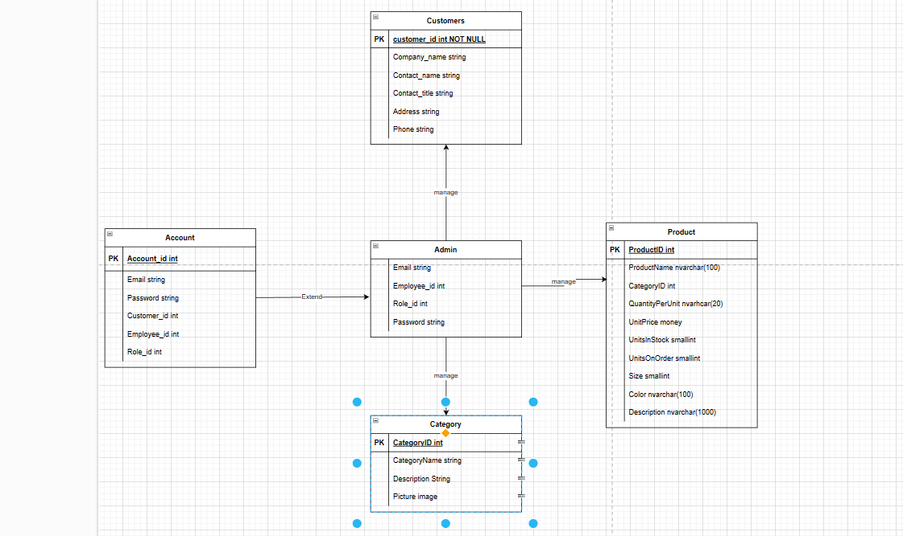

### b. Class Specifications

#### Order

| **No** | **Method** | **Description** |
| --- | --- | --- |
| *01* | *getter/setter* | *Get value of private attributes* |
|  |  |  |

#### Customer

| **No** | **Method** | **Description** |
| --- | --- | --- |
| *01* | *getter/setter* | *Get value of private attributes* |
|  |  |  |

#### Category

| **No** | **Method** | **Description** |
| --- | --- | --- |
| *01* | *getter/setter* | *Get value of private attributes* |
|  |  |  |

#### Product

| **No** | **Method** | **Description** |
| --- | --- | --- |
| *01* | *getter/setter* | *Get value of private attributes* |
|  |  |  |

### DBContext Class

| No | Method | Description |
| --- | --- | --- |
| 01 | getConnection() | class attempts to establish a connection to the database by using the given database url. |

## *c. Sequence Diagram(s)*

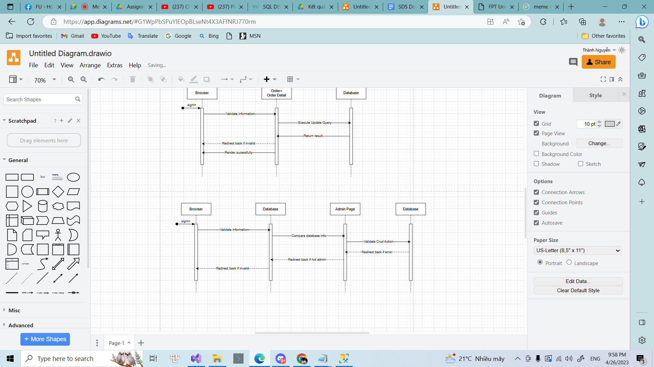

### d. Database Queries

_dbContext.Customers.toList();

_dbContext.Accounts.toList();

_dbContext.Products.toList();

_dbContext.Categories.toList();

## 5. ProductList

### a. Class Diagram

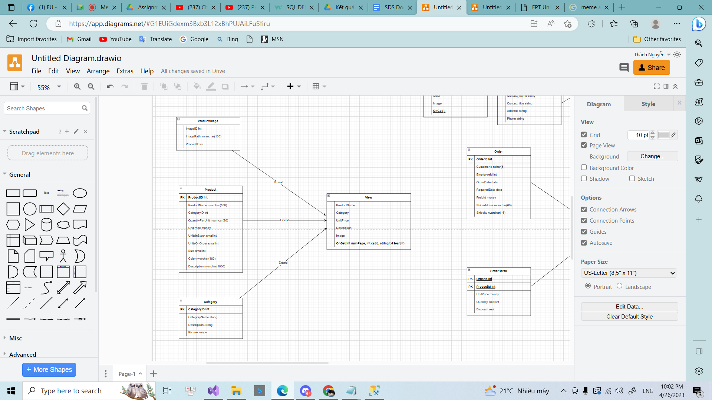

### b. Class Specifications

#### Product

| **No** | **Method** | **Description** |
| --- | --- | --- |
| *01* | *getter/setter* | *Get value of private attributes* |
|  |  |  |

### DBContext Class

| No | Method | Description |
| --- | --- | --- |
| 01 | getConnection() | class attempts to establish a connection to the database by using the given database url. |

## *c. Sequence Diagram(s)*

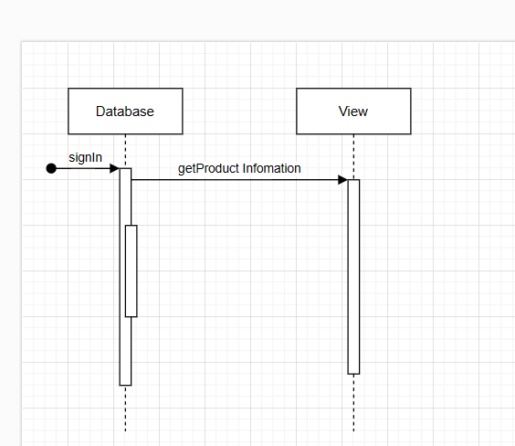

### d. Database Queries

_dbContext.Products.toList();

## 6. Filter

### a. Class Diagram

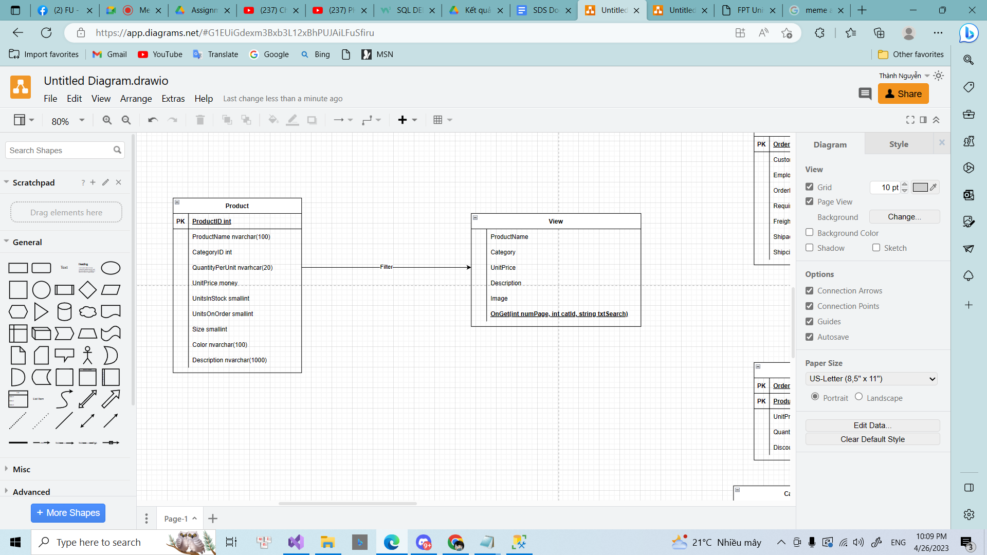

### b. Class Specifications

#### Product

| **No** | **Method** | **Description** |
| --- | --- | --- |
| *01* | *getter/setter* | *Get value of private attributes* |
|  |  |  |

### DBContext Class

| No | Method | Description |
| --- | --- | --- |
| 01 | getConnection() | class attempts to establish a connection to the database by using the given database url. |

## *c. Sequence Diagram(s)*

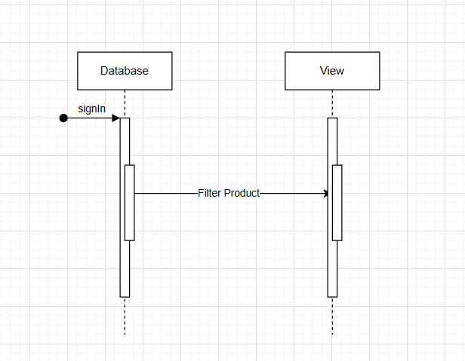

### d. Database Queries

productPerPage.Where(p => p.ProductId.ToString().Contains(txtSearch)

|| p.ProductName.Contains(txtSearch)

|| p.UnitPrice.ToString().Contains(txtSearch)

|| p.QuantityPerUnit.Contains(txtSearch)

|| p.UnitsInStock.ToString().Contains(txtSearch)

|| p.Category.CategoryName.Contains(txtSearch)

)

.ToList();

## 7. Search

### a. Class Diagram

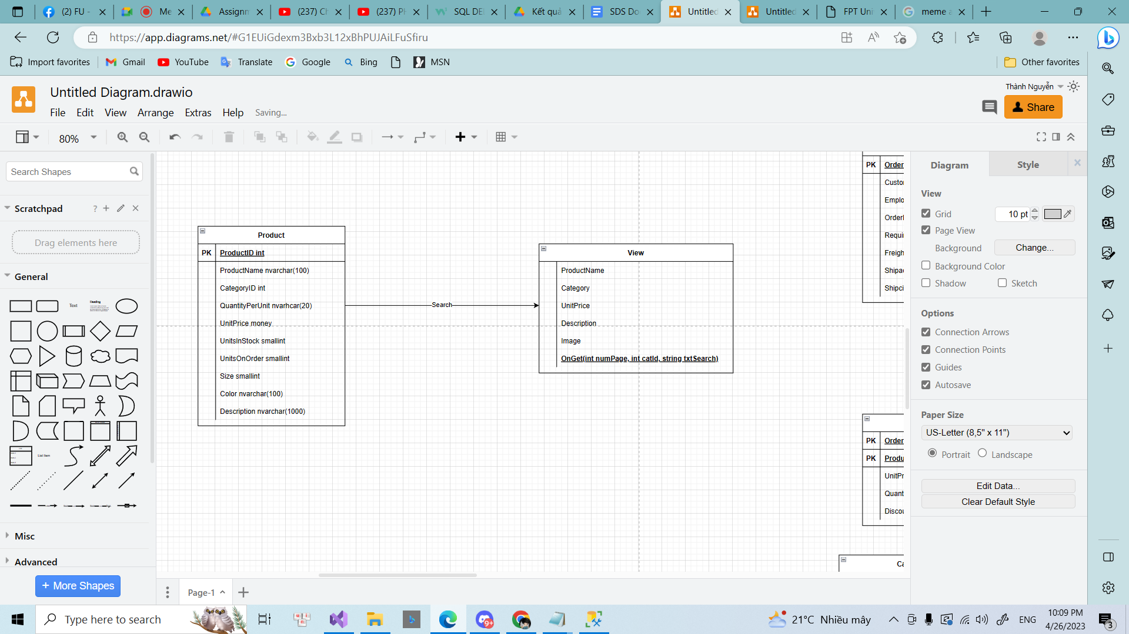

### b. Class Specifications

#### Product

| **No** | **Method** | **Description** |
| --- | --- | --- |
| *01* | *getter/setter* | *Get value of private attributes* |
|  |  |  |

### DBContext Class

| No | Method | Description |
| --- | --- | --- |
| 01 | getConnection() | class attempts to establish a connection to the database by using the given database url. |

## *c. Sequence Diagram(s)*

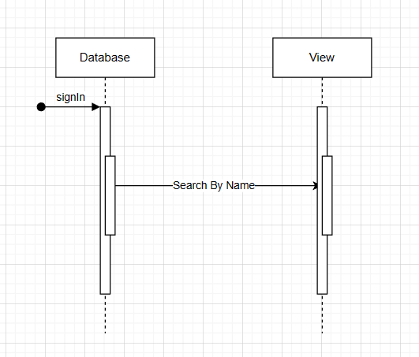

### d. Database Queries

_dbContext.Products.Where(p => p.name.Contain(search)).toList();

## 8. Admin Dashboard

### a. Class Diagram

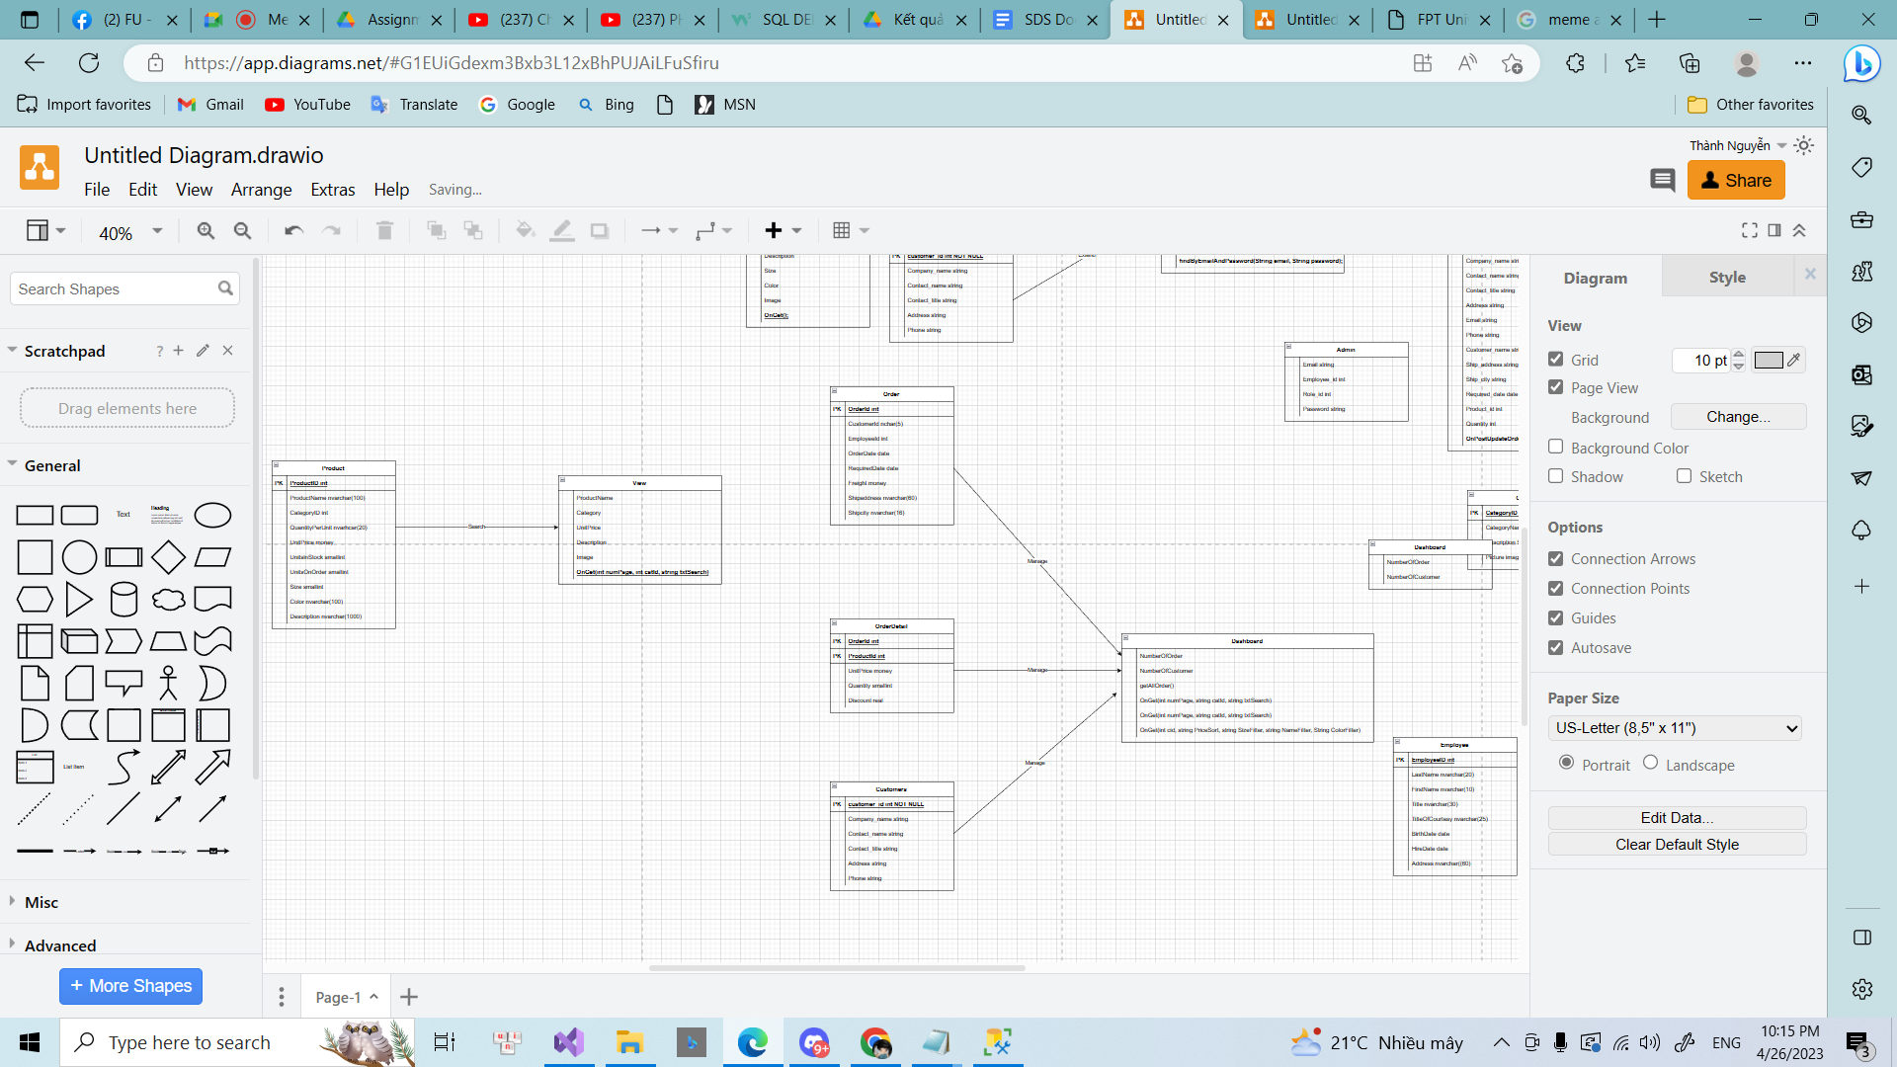

### b. Class Specifications

#### Order

| **No** | **Method** | **Description** |
| --- | --- | --- |
| *01* | *getter/setter* | *Get value of private attributes* |
|  |  |  |

#### Customer

| **No** | **Method** | **Description** |
| --- | --- | --- |
| *01* | *getter/setter* | *Get value of private attributes* |
|  |  |  |

### DBContext Class

| No | Method | Description |
| --- | --- | --- |
| 01 | getConnection() | class attempts to establish a connection to the database by using the given database url. |

## *c. Sequence Diagram(s)*

## 

### d. Database Queries

_dbContext.Customers.toList();

_dbContext.Order.toList();

## 9. View profile

### a. Class Diagram

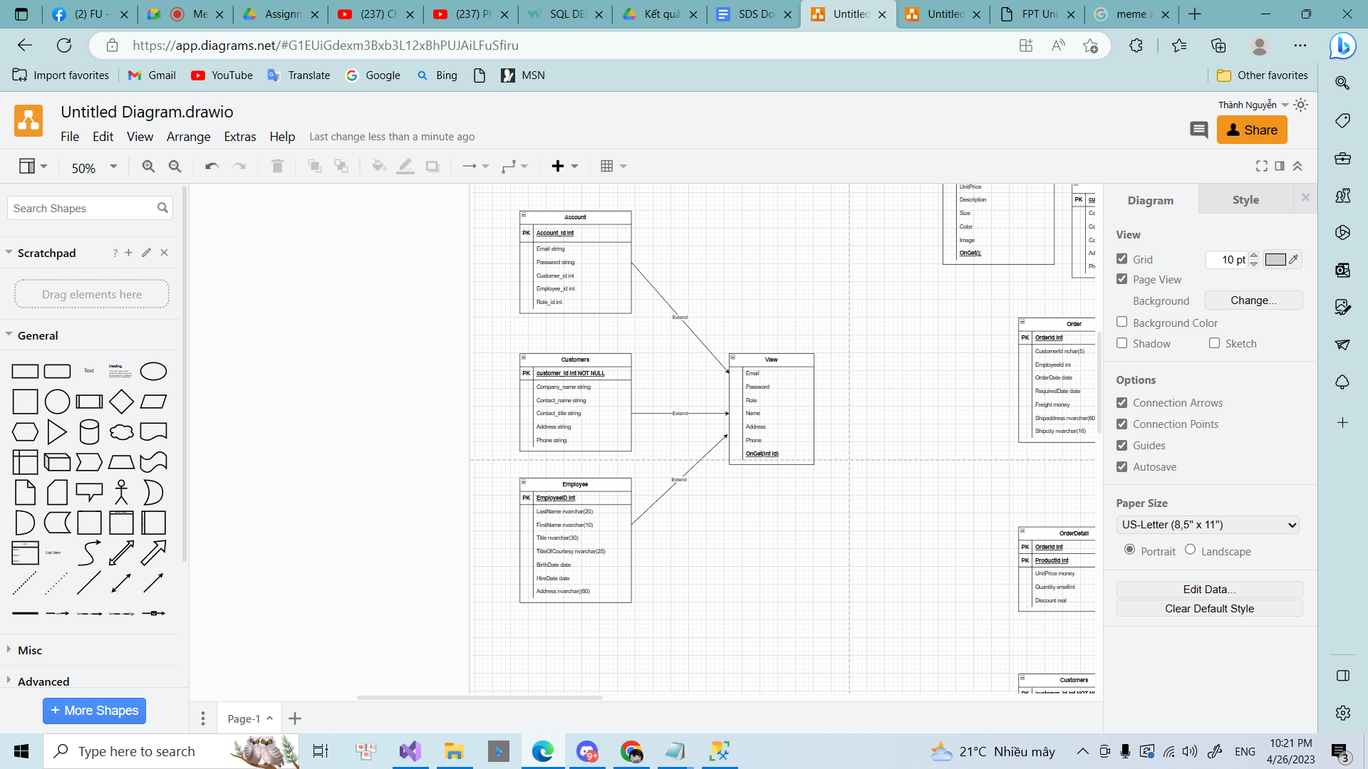

### b. Class Specifications

#### Customer

| **No** | **Method** | **Description** |
| --- | --- | --- |
| *01* | *getter/setter* | *Get value of private attributes* |
|  |  |  |

#### Account

| **No** | **Method** | **Description** |
| --- | --- | --- |
| *01* | *getter/setter* | *Get value of private attributes* |
|  |  |  |

#### Employee

| **No** | **Method** | **Description** |
| --- | --- | --- |
| *01* | *getter/setter* | *Get value of private attributes* |
|  |  |  |

### DBContext Class

| No | Method | Description |
| --- | --- | --- |
| 01 | getConnection() | class attempts to establish a connection to the database by using the given database url. |

## *c. Sequence Diagram(s)*

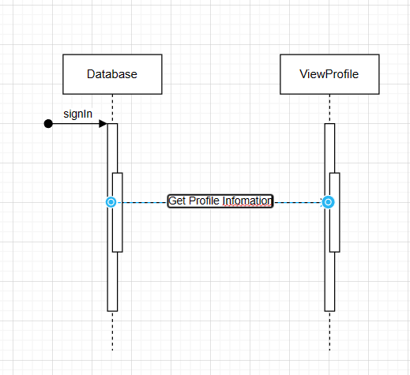

### d. Database Queries

_dbContext.Customers.SingleOrDefault(c => c.id = id);

_dbContext.Accounts.SingleOrDefault(a => a.id = id);

_dbContext.Employee.SingleOrDefault.(e => e.id = id);

## 10. Product Detail

### a. Class Diagram

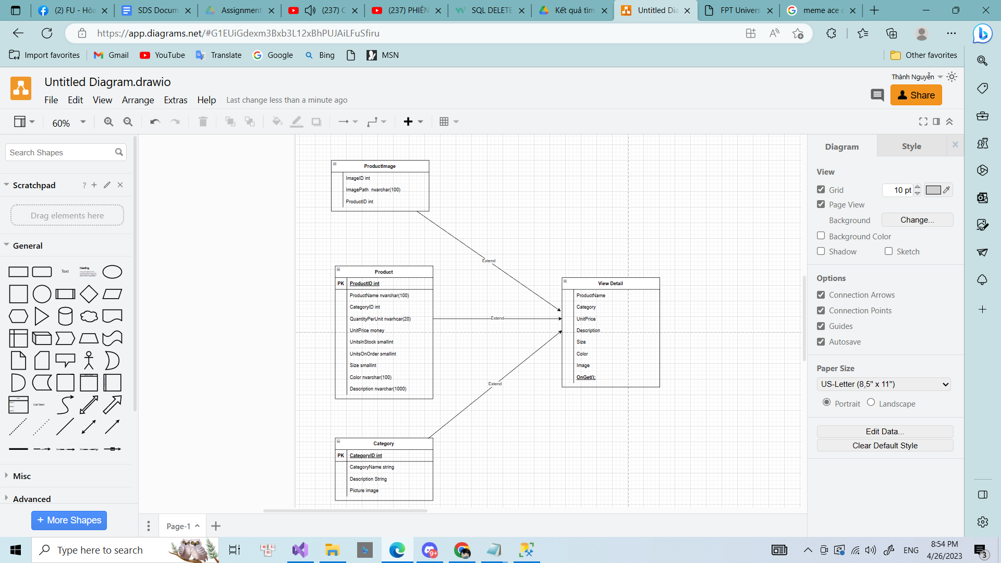

### b. Class Specifications

#### Product

| **No** | **Method** | **Description** |
| --- | --- | --- |
| *01* | *getter/setter* | *Get value of private attributes* |
|  |  |  |

#### Category

| **No** | **Method** | **Description** |
| --- | --- | --- |
| *01* | *getter/setter* | *Get value of private attributes* |
|  |  |  |

#### ProductImage

| **No** | **Method** | **Description** |
| --- | --- | --- |
| *01* | *getter/setter* | *Get value of private attributes* |
|  |  |  |

### 

## *c. Sequence Diagram(s)*

### 

### d. Database Queries

_dbContext.Products.SingleOrDefault(c => c.id = id)

_dbContext.Categories.SingleOrDefault(a => a.id = categoryId);

_dbContext.ProductImage.SingleOrDefault.(e => e.ProductId = id);